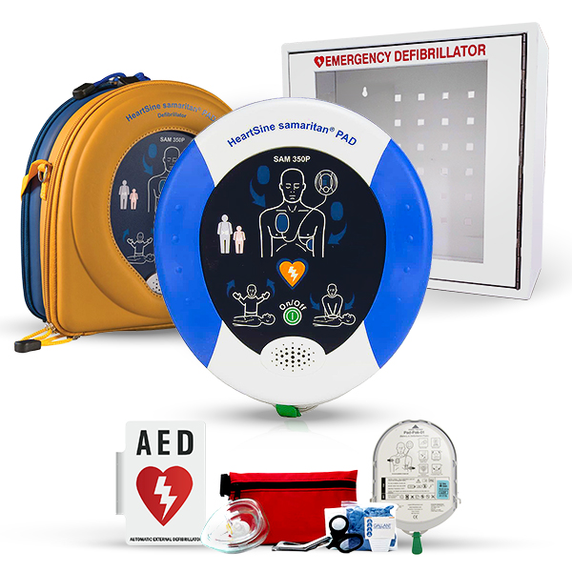

This innovative device is designed to quickly and safely deliver life-saving shocks to those experiencing sudden cardiac arrest (SCA). With clear voice and visual prompts, even those without prior training can use the HeartSine Samaritan PAD 350P AED with confidence.
The HeartSine Samaritan PAD 350P AED is built with a sleek and compact design that makes it easy to transport and store, while also being highly durable and resistant to environmental factors. Additionally, the device features advanced technology such as CPR coaching and escalating energy, ensuring that the appropriate shock strength is delivered based on the patient's needs.
Not only is the HeartSine Samaritan PAD 350P AED highly effective, it is also cost-effective, with a low total cost of ownership and a long battery life. Plus, with a 8-year warranty and the ability to easily update software, the HeartSine Samaritan PAD 350P AED is a smart investment for any workplace or community setting.
Ensure the safety of those around you with the HeartSine Samaritan PAD 350P AED. Order now and have peace of mind knowing that you're prepared for any sudden cardiac emergency.
Parts lifespan
Pad-Pak (battery & pads cartridge): 4 years
Type of AED
Semi-automatic AED (shock button required)
Warranty
8 years

